# Queena Lin

CIS 310 Homework 7

# Assignment 7: A review of chapters 1 to 5

**CIS 310 FALL 2019**

**Please do your best to answer the following six questions, using Visio or Lucid Chart.**

**1. Typically, a patient staying in a hospital receives medications that have been ordered by a particular doctor. Because the patient often receives several medications per day, there is a 1:M relationship between PATIENT and ORDER. Similarly, each order can include several medications, creating a 1:M relationship between ORDER and MEDICATION.**

1. **Identify the business rules for PATIENT, ORDER, and MEDICATION.**

Business rule of PATIENT

* A PATIENT can have many (medical) ORDER written for him. Each (medical) ORDER is written to a single PATIENT.

Business rule of ORDER

* Each (medical) ORDER prescribes many MEDICATIONS. Each MEDICATIONS can be prescribed in many ORDER.

Business rule of MEDICATION

* Each MEDICATION can be prescribed in many ORDER. Each (medical) ORDER can prescribe many MEDICATIONS.

1. **Create a Crow's Foot ERD that depicts a relational database model to capture these business rules.**

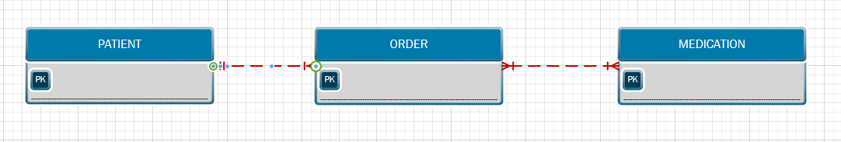

The first diagram consisted on a M:N relationship which I broken down into 1:M relationship by creating the entity ORDER_MED.

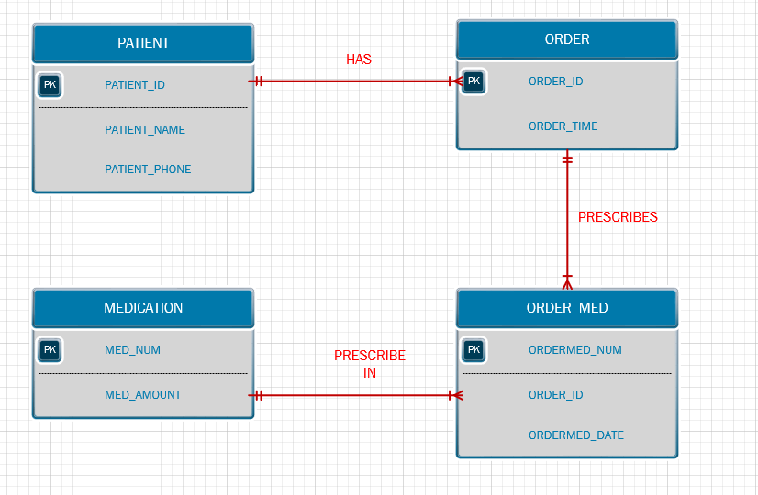

**2. United Broke Artists (UBA) is a broker for not-so-famous painters. UBA maintains a small network database to track painters, paintings, and galleries. A painting is painted by a particular artist, and that painting is exhibited in a particular gallery. A gallery can exhibit many paintings, but each painting can be exhibited in only one gallery. Similarly, a painting is painted by a single painter, but each painter can paint many paintings. Using PAINTER, PAINTING, and GALLERY, in terms of a relational database:**

**a. What tables would you create, and what would the table components be? Identify each table with attributes**

* 3 tables are needed; PAINTERS, PAINTINGS, and GALLERY
* The attribute for PAINTERS table consisted of PAINT_NUM, PAINT_LNAME, PAINT_FNAME, PAINT_INTIAL
* The attribute for PAINTINGS table includes: PAINTING_NUM, PAINTING_TITLE, PAINTER_NUM, and GALLERY_NUM
* The attribute of GALARY table is composed of GALLERY_NUM, GALLERY_NAME, GALLERY_WEB

1. **Identify applicable business rules for each entities (tables)**

* A painter can paint may paintings.
* Each painting is painted by only one painter.

• A gallery can exhibit many paintings.

• A painter can exhibit paintings at more than one gallery at a time

• Each painting is exhibited in only one gallery

1. **Show the relationships in a Crow’s Foot diagram**

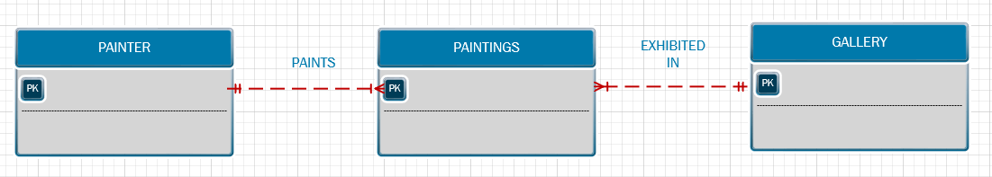

**3. Using the ERD you created from Problem 2, create the relational diagram. (Create an appropriate collection of attributes for each of the entities. Make sure you use the appropriate naming conventions to name the attributes.)**

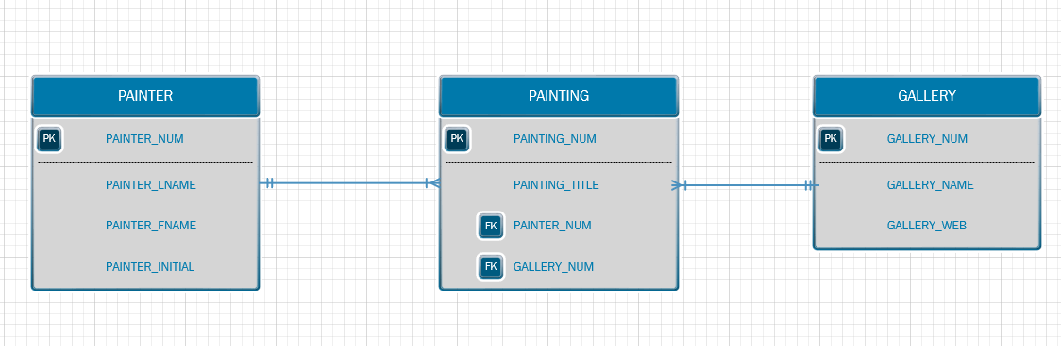

**4. Convert the ERD from Problem 1 into the corresponding UML class diagram.**

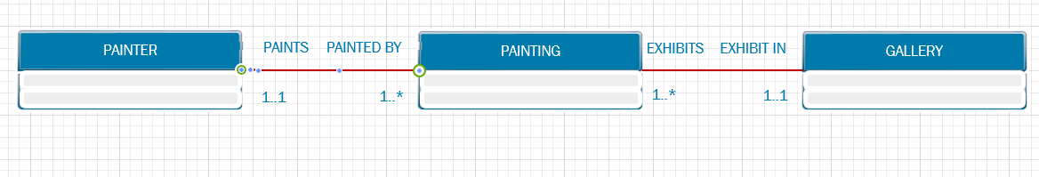

**5. Identify the business rules from the depicted relationships in the Crow’s Foot ERD shown in Figure 5.1**

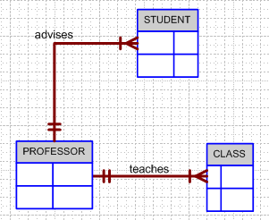

**Figure 5.1 The Crow’s Foot ERD for Problem 5**

Business Rule

* One professor advises many students
* Each class is taught by one professor
* One professor teaches many class
* Each Student is advised by one professor

**6. Create a Crow’s Foot ERD to include the following business rules for the ProdCo company:**

1. **Each sales representative writes many invoices.**
2. **Each invoice is written by one sales representative.**
3. **Each sales representative is assigned to one department.**
4. **Each department has many sales representatives.**
5. **Each customer can generate many invoices.**
6. **Each invoice is generated by one customer.**

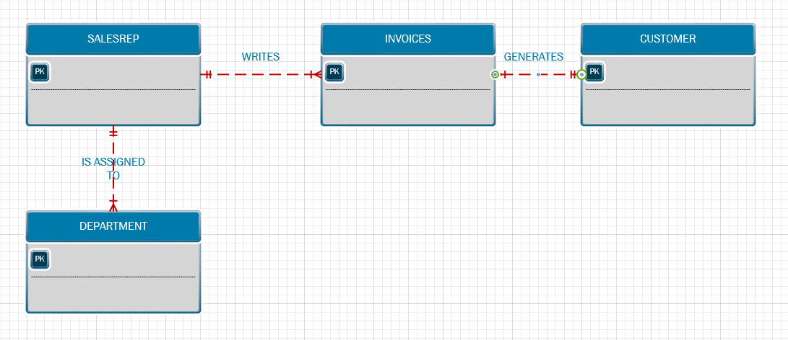

**7. What is normalization and why it’s important?**

Normalization is the process of organizing a database to reduce redundancy and improve data integrity. Normalization helps decrease the likelihood of producing bad table structures and helps the table beome more clean.

1. **describe the three forms**

**- The 1NF normalization:** all the key attributes are defined with no repeating groups in the table, Furthermore, all the attributes are dependent on the primary key

**- The 2NF normalization:** It is in 1NF and includes no partial dependencies which no attribute is dependent on only a portion of the primary key.

**- The 3NF normalization:** It is in 2NF and includes no transitive dependencies

1. **describe the data modeling checklist**

 Help ensure that you perform data-modeling tasks successfully

**BUSINESS RULES**

* Ensure that all business rules are written precisely, clearly, and simply. The business rules must help identify entities, attributes, relationships, and constraints.
* Identify the source of all business rules, and ensure that each business rule is justified, dated, and signed off by an approving authority.

**DATA MODELING**

* **Naming conventions:** Should be nouns that are familiar to business and should be short and meaningful and documents abbreviation
* Should be unique within the model
* For composite entities, may include a combination of abbreviated names of the entities linked through the composite entity
* Attribute names:
* Should use the entity abbreviation as a prefix and should be descriptive of the characteristic
* Should use suffixes such as _ID, _NUM, or _CODE for the PK attribute
* No special characters
* Relationship names should contain verbs that demonstrates the nature of the relationship

**Entities:**

* Each entity should represent a single subject.
* All entities should be in 3NF or higher. Any entities below 3NF should be justified.

**Attributes:**

* Should be simple and easy to understand
* Should document default values, constraints, synonyms, and aliases
* Non-key attributes must be fully dependent on the PK attribute

**Relationships:**

* Should clearly identify relationship participants
* Should clearly define participation, connectivity, and document cardinality